D4A Website Content

Website Template: https://html.awaikenthemes.com/artistic/service-single.html

Page 5: Asset Management Software
Website Section Snippet | Content
Banner Content | Track, maintain, and optimize assets with real time visibility and control.  CTA: Book Demo Now
 | Organizations today need complete visibility into how assets are acquired, used, and maintained. D4A’s asset management software Qatar and global provides one central platform to track, monitor, and optimize every asset. From IT equipment and vehicles to machinery and digital tools, our system simplifies asset control, prevents losses, and ensures that compliance and performance standards are always met.
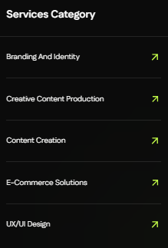 | Vertical Solutions Category  ReadyMix Concrete ERP  Stakeholder Management  Property Management  Procurement Software  University Management
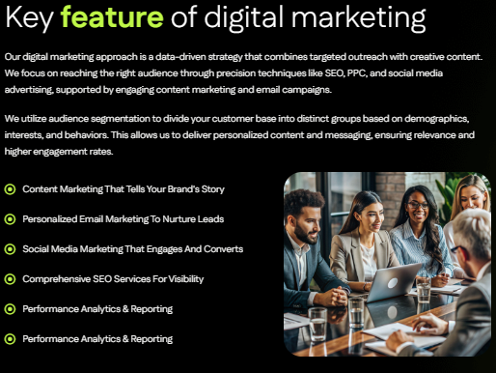 | Key Features of D4A Asset Management Software  Gain complete lifecycle control with tools built for enterprises and government agencies.  - Enterprise Asset Management Platform: Central solution to record, categorize, and manage assets across all departments.  - Fixed Asset Tracking System: Real time tracking of location, usage, and condition to prevent underutilization or loss.  - Digital Asset Register Software: Secure and searchable record of all assets with full audit trails.  - QR Code Asset Tracking: Scan and update asset information instantly using QR codes and mobile devices.  - Preventive Maintenance Software: Schedule and manage preventive and corrective maintenance for higher asset availability.  - Analytics and Dashboards: Access real time insights on utilization, depreciation, and maintenance costs.
 | Assess → Automate → Optimize  Our Process of Asset Management Digitization  Assess  Review your current asset base, identify challenges, and define compliance needs.  Automate  Set up asset categories, configure depreciation rules, and enable QR code tracking. Integrate with ERP and accounting systems.  Optimize  Empower teams with real time dashboards, mobile scanning, and reports that improve asset utilization and accountability.
Why Choose D4A?
- Cloud based platform with mobile access for teams anywhere.
- Designed to meet global requirements with support for regional regulations including Qatar.
- QR code enabled asset tracking for field and office teams.
- Easy integration with D4A ERP, HRMS, and financial systems.
- Scalable for SMEs, enterprises, and public agencies.
- Supported by a dedicated implementation and support team.

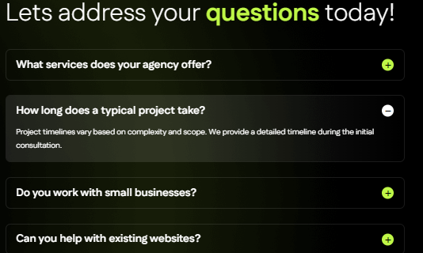 | Q1: What makes D4A the best asset management solution in Qatar and globally?  Our platform combines fixed asset tracking, QR scanning, digital registers, and preventive maintenance into one system that scales across industries.  Q2: Can it integrate with ERP and finance systems?  Yes. D4A integrates with ERP, HRMS, and finance platforms to ensure depreciation and reporting accuracy.  Q3: How does QR code asset tracking work?  Assets are tagged with QR codes and updated through mobile scanning, which improves accuracy and reduces manual errors.  Q4: Is this solution suitable for smaller organizations?  Yes. It is configurable for SMEs while also robust enough for large enterprises and government entities.  Q5: Can it track digital as well as physical assets?  Yes. D4A’s digital asset register software records both physical assets and intangible items such as licenses and warranties.
Meta Content:
Meta Title (Max 60 Characters): Asset Management Software Qatar | Fixed Asset Tracking
Meta Description (Max 160 Characters): D4A’s asset management software Qatar and global solution help track, tag, and optimize assets with QR codes and preventive maintenance tools.
Image Alt Text Content:
Hero Banner / Main Visual
Asset management software Qatar and global – D4A solution for fixed asset tracking, QR scanning, and lifecycle visibility.
Features Icons / Illustrations
- Enterprise Asset Management Platform: Centralized system for full control of assets.
- Fixed Asset Tracking System: Real time dashboards for asset status and depreciation.
- Digital Asset Register Software: Secure records with complete audit history.
- QR Code Asset Tracking: Mobile scanning and instant asset updates.
- Preventive Maintenance Software: Automated scheduling and work order tracking.
Process Section (Illustration / Workflow Graphic)
Assess → Automate → Optimize – D4A process for asset management.
Dashboard Screenshot / Analytics Image
Real time dashboards for asset utilization, costs, and performance tracking.
CTA / Free Trial Visual
Book free demo of D4A asset management software Qatar – a complete asset tracking and management solution.

