D4A Website Content

Website Template: https://html.awaikenthemes.com/artistic/service-single.html

Page 4: Procurement Software
Website Section Snippet | Content
Banner Content | Automate purchase orders, vendor management, and source to pay workflows.  CTA: Try Free Demo
 | Managing procurement globally has never been easier. D4A’s procurement software Qatar and worldwide empowers businesses, government agencies, and enterprises to automate purchase requests, vendor approvals, and payment processes. From requisition to supplier collaboration, our digital procurement solution ensures cost efficiency, compliance, and transparency across the entire procurement lifecycle.
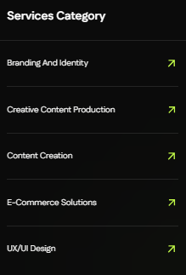 | Vertical Solutions Category  ReadyMix Concrete ERP  Stakeholder Management  Asset Management  Property Management  University Management
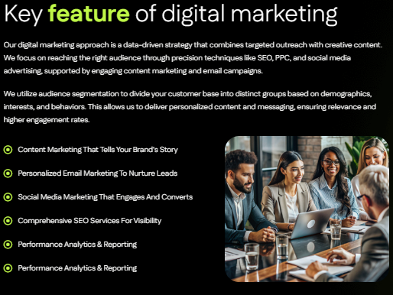 | Key Features of D4A Procurement Software  Streamline sourcing, approvals, and supplier management with D4A’s advanced platform. Core features include:  - Purchase Order Automation: Create, approve, and track purchase orders digitally to eliminate paperwork and delays.  - Vendor Management Software: Maintain a centralized vendor database with ratings, compliance checks, and performance insights.  - Digital Procurement Workflow: Automate requisitions, approvals, and payments with rule-based workflows.  - Source-to-Pay Platform: Manage the entire procurement cycle – from request to invoice clearance – within one solution.  - B2B Procurement Digitization: Enable bulk ordering, supplier negotiations, and contract compliance digitally.  - Analytics & Dashboards: Real-time spend visibility, supplier performance, and procurement KPIs.
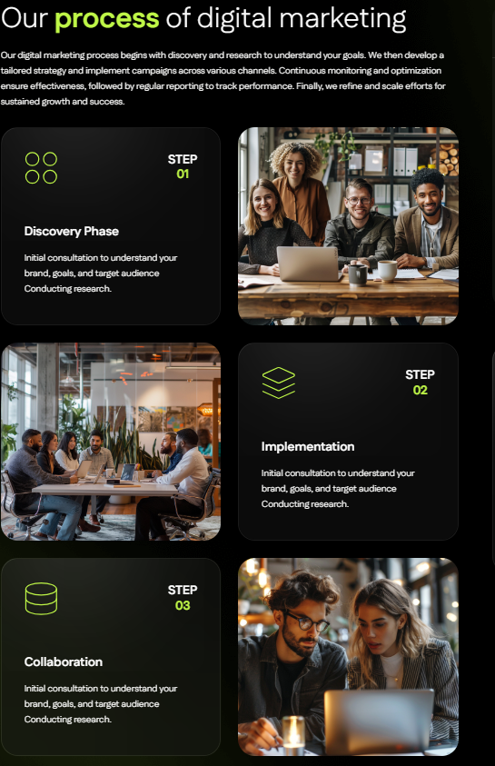 | Requisition → Approval → Fulfillment  Our Process of Procurement Digitization  Requisition  Capture purchase requests with automated templates and multi-department workflows.  Approval  Digitize purchase approvals with audit-ready, multi-level authorization.  Fulfillment  Enable supplier collaboration, order tracking, and on-time delivery with integrated payment systems.
Why Choose D4A?
- Cloud-based procurement platform accessible anytime, anywhere.
- Built for enterprises worldwide, with compliance-ready frameworks (including Qatar regulations).
- Streamlines sourcing, supplier engagement, and payment cycles.
- Integrates seamlessly with D4A ERP, HRMS, and finance systems.
- Scalable for SMEs, enterprises, and public agencies.
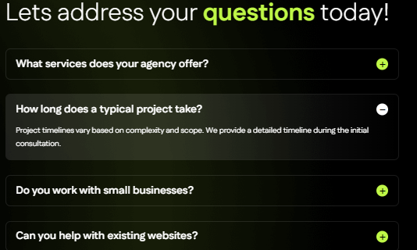 | Q1: What makes D4A the best procurement software in Qatar and globally?  Our solution combines purchase order automation, vendor tracking, workflows, and analytics into one platform adaptable to regional and international compliance.  Q2: Can it integrate with ERP and finance systems?  Yes. D4A integrates with ERP and accounting tools to sync budgets, invoices, and payment cycles.  Q3: How does vendor management work?  The system centralizes vendor data, compliance status, and performance reports for smarter sourcing decisions.  Q4: Does it support end-to-end automation?  Yes. As a full source-to-pay platform, it digitizes requisitions, approvals, and invoice clearance.  Q5: Is it suitable for SMEs as well as large organizations?  Absolutely. Our solution scales seamlessly from startups to global enterprises.
Meta Content:
Meta Title (Max 60 Characters): Procurement Software Qatar | Vendor & Order Management
Meta Description (Max 160 Characters): Discover D4A’s global procurement software in Qatar. Automate purchase orders, vendor management & workflows. Book a free demo today.
Image Alt Text Content:
Hero Banner / Main Visual
Procurement software Qatar and global: D4A ERP solution for purchase order management and vendor tracking.
Features Icons / Illustrations
- Purchase Order Automation: Dashboard for creating and tracking digital POs.
- Vendor Management Software: Vendor performance & compliance dashboard.
- Digital Procurement Workflow: Automated procurement workflow system.
- Source-to-Pay Platform: End-to-end procurement cycle software.
- B2B Procurement Digitization: Bulk ordering and supplier negotiation software.
Process Section (Illustration / Workflow Graphic)
D4A procurement workflow: Requisition → Approval → Fulfillment.
Dashboard Screenshot / Analytics Image
Real-time dashboards for spend analysis and vendor performance.
CTA / Free Trial Visual
Book free demo of D4A procurement software Qatar – automate purchase orders and vendor management globally.

