D4A Website Content

Website Template: https://html.awaikenthemes.com/artistic/service-single.html

Page 3: Property Management Software
Website Section Snippet | Content
Banner Content | Streamline property operations with automated leasing, billing, and tenant tracking.  CTA: Schedule Demo
 | Managing properties worldwide has never been easier. D4A’s property lease management system empowers real estate owners, facility managers, and leasing agents to automate daily operations from tenant onboarding and lease contracts to billing, accounting, and reporting.
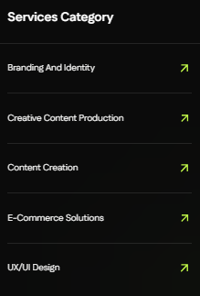 | Vertical Solutions Category  ReadyMix Concrete ERP  Stakeholder Management  Asset Management  Procurement Software  University Management
 | Key Features of D4A Property Management Software in Qatar  Streamline leasing, tenant management, and financial operations with D4A’s advanced property management software. Our core features include:  - Lease Tracking Software: Digitally monitor lease agreements, renewals, and expirations.  - Tenant & Lease Contract Management: Automate move-in/move-out, generate multilingual agreements, and enable e-signatures.  - Property Financial Suite: Billing, invoicing, PDC tracking, chart of accounts, and detailed property financial reporting.  - Land Leasing Software: Simplify leasing for plots, commercial spaces, and mixed-use facilities.  - Approval Matrix & Workflow Automation: Multi-level approvals for requests, procurement, and maintenance.  - Facility & Asset Management: Centralized maintenance, work orders, and asset tracking.  - Real-time BI Dashboards: AI-powered analytics for occupancy rates, budget vs. actual, and ROI tracking.
 | Discovery → Implementation → Collaboration  Our Process of Leasing & Property Management Digitization:  Discovery  Understand your property portfolio, goals, and operational challenges.  Implementation  Configure workflows, set up leasing templates, and integrate with existing tools like property management Zoho if needed.  Collaboration  Enable stakeholders with tenant portals, manager dashboards, and automated reporting.
Why Choose D4A?
- Cloud-based & mobile-friendly software for property managers on-the-go.
- Fully compliant with Qatar’s real estate and leasing regulations.
- Multi-lingual lease contracts & e-signatures for faster processing.
- Scalable for small businesses, enterprises, and free-zone operators.

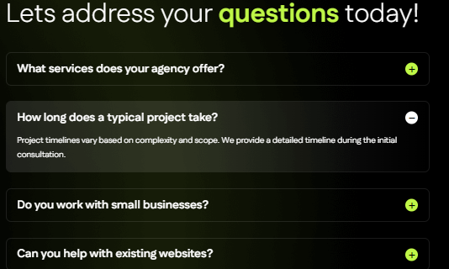 | What makes D4A the best property management software in Qatar and globally?  D4A combines lease tracking software, property financials, tenant portals, and facility management into one platform, making it effective both for Qatar’s property market and international operations.  Can D4A integrate with existing systems like Zoho?  Yes, our software supports integrations, including property management Zoho tools for smooth workflow continuity.  Do you support land and bulk leasing operations?  Absolutely. Our land leasing software and bulk booking modules handle everything from unit allocation to contract generation.  Is it suitable for small businesses?  Yes. D4A is flexible, making it ideal for SMEs, enterprises, and large real estate firms.
Meta Content:
Meta Title (Max 60 Characters): Property Management Software Qatar | Global Leasing Solutions
Meta Description (Max 160 Characters): Discover D4A’s all-in-one property management software Qatar & beyond. Automate leasing, tenant management, financials & reporting. Free demo available.
Image Alt Text Content:
Hero Banner / Main Visual
- Property management software Qatar & global ERP solution for leasing and tenant management
Features Icons / Illustrations
- Lease Tracking Software: Lease tracking software dashboard for real estate managers
- Tenant Management: Tenant self-service portal and digital onboarding solutions
- Lease Contract Management: Property lease management system with multilingual e-sign agreements
- Financial Accounting: Property financial reporting and billing software
- Facility & Asset Management: Cloud-based facility management and asset tracking solution
- Land Leasing Software: Land leasing software for commercial and residential properties
Process Section (Illustration / Workflow Graphic)
- D4A property management Zoho integrated workflow for discovery, implementation, collaboration
Dashboard Screenshot / Analytics Image
- Real-time BI dashboards for property management, occupancy, revenue, and expenses
CTA / Free Trial Visual
- Book free demo of D4A leasing management software Qatar and global property automation platform

