D4A Website Content

Website Template: https://html.awaikenthemes.com/artistic/service-single.html

Page 4: University Management Software
Website Section Snippet | Content
Banner Content | Manage admissions, courses, exams, and campus operations in one platform  CTA: Book Demo Now
 | Managing a university involves balancing academics, administration, and student services all at once. D4A’s University Management Software Qatar and global ERP brings everything together on one platform to create efficiency, accountability, and better student outcomes.
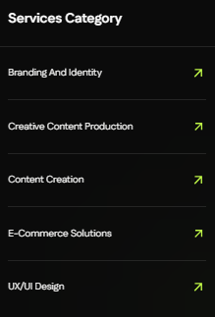 | Vertical Solutions Category  ReadyMix Concrete ERP  Stakeholder Management  Property Management  Procurement Software  Asset Management
 | Key Features of D4A University Management Software  Every institution needs a system that reduces paperwork, ensures compliance, and improves student engagement. D4A’s platform covers academics, campus operations, and administration in one solution.  - University ERP Qatar: End to end ERP covering admissions, courses, exams, and finance.  - Student Management System Qatar: Centralized student records for enrollment, attendance, and grading.  - Academic ERP Qatar: Streamlined workflows for curriculum planning, exams, and academic compliance.  - Student Attendance and Grading System: Digital tools to capture attendance, publish grades, and track progress.  - Campus Automation Software: Simplified hostel, transport, and library management with integrated modules.  - Analytics and Dashboards: Real time insights for faculty, administration, and decision makers.
 | Enroll → Manage → Grow  Digitization is not just about automation — it is about creating a better learning environment. Our structured approach ensures universities get value at every stage.  Enroll  Digitize admissions with online applications, eligibility checks, and approvals.  Manage  Automate academic and administrative workflows including attendance, exams, and finance.  Grow  Use dashboards and reports to improve planning, resource allocation, and student success.
Why Choose D4A?
- One platform for academics, campus services, and administration.
- Built for universities of all sizes, including multi campus groups.
- Designed for global institutions while supporting local regulations in Qatar.
- Cloud access for administrators, faculty, and students.
- Integrates with ERP, HRMS, and finance systems.

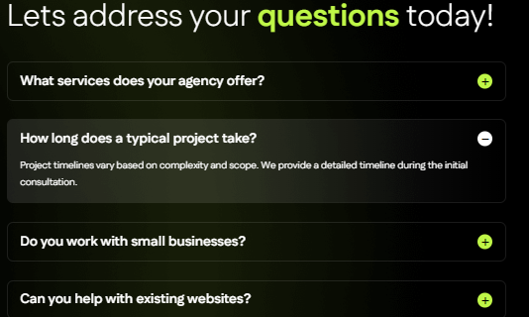 | Q1: Why is D4A considered one of the best University Management Software in Qatar and globally?  Because it brings together admissions, academics, attendance, grading, and campus services in one integrated system.  Q2: Can the system manage multiple campuses?  Yes. Our University ERP Qatar provides centralized control with detailed dashboards for each campus.  Q3: How does the student management system help?  It gives administrators complete visibility of student records, attendance, grading, and academic history.  Q4: Does it include attendance and grading features?  Yes. The student attendance and grading system captures records digitally, publishes grades, and generates reports.  Q5: Can it manage hostels, transport, and libraries?  Yes. Our campus automation software supports non-academic services alongside core academic operations.
Meta Content:
Meta Title (Max 60 Characters): University Management Software | Student ERP Qatar
Meta Description (Max 160 Characters): D4A’s University Management Software Qatar unifies admissions, academics, grading, and campus services in one ERP. Book a free demo today.
Image Alt Text Content:
• Hero Banner / Main Visual
University Management Software Qatar and global ERP for admissions, academics, grading, and campus services
• Features Icons / Illustrations
- University ERP Qatar system for admissions, curriculum, exams, and finance management
- Student management system Qatar with digital attendance, grades, and student records
- Academic ERP Qatar for scheduling, compliance, and academic performance tracking
- Student attendance and grading system dashboard with analytics and progress reports
- Campus automation software for hostels, transport, and library management
• Process Section (Illustration / Workflow Graphic)
University ERP workflow for enrollment, management, and institutional growth
• Dashboard Screenshot / Analytics Image
University ERP dashboard with student attendance, grading, and performance insights
• CTA / Free Trial Visual
Free demo of D4A University Management Software Qatar for higher education ERP needs

